PRE-PROPOSAL APPLICATION PRO FORMA

2nd Competitive Call for Research Proposals
International Wheat Yield Partnership

BREAKTHROUGH DISCOVERIES THAT WILL LEAD TO LARGE INCREASES IN WHEAT GRAIN YIELDS

Launch: 19 December 2016

Closing Date for Pre-Proposals: 3 March 2017 24:00 GMT

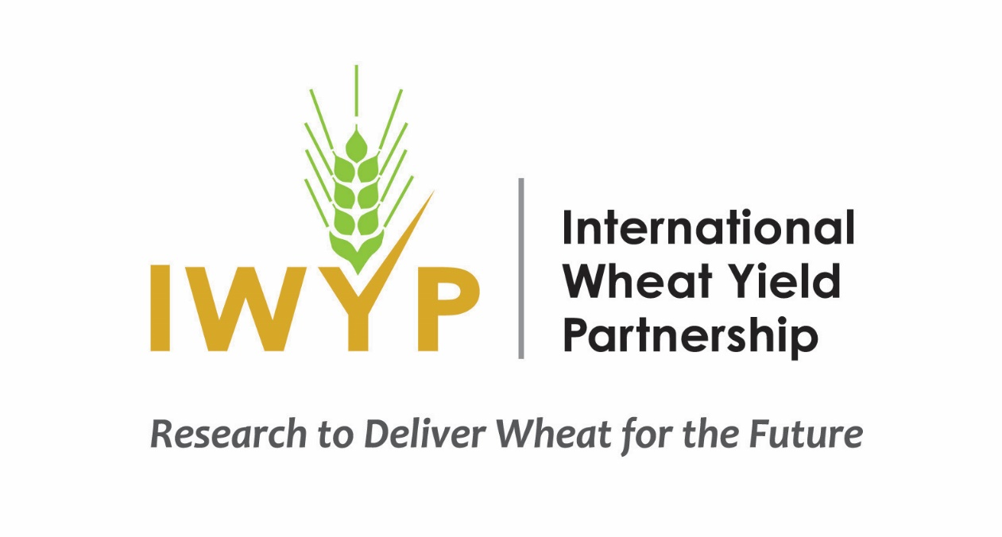

APPLICANTS MUST ADHERE TO THIS FORMAT AND INSTRUCTIONS HEREIN

PRE-PROPOSAL PRO FORMA

GENERAL: USE ONLY LETTER OR A4 SIZE PAPER, 10-12 SIZE FONT, ½ TO 1 INCH MARGINS

1) Title: _________________________________________________________________

2) A. Project Lead, and B. Principal Investigators
- Name(s):
- Email addresses:
- Institution(s) and address(es):

3) Private Industry Partner(s) if applicable
- Company and address:
- Name, title and email address of contact:

4) A summary project description
Length: maximum 3 pages of a letter or A4 size page, one side only (see Application Guidelines page 6 for content to be included).

5) Amount of funding requested
Term of Project (in years): _________
Cash requested from IWYP: US$_______________
Any in-kind: US$_______________________
Source: ____________________
Any cost-share: US$________________
Source: ____________________

6) Budget
Estimate of costs: Give as total for the project term in $ US. Use the format below.

ITEM | YEAR 1 | YEAR 2 | YEAR 3 | TOTAL
Personnel (wage + fringe) | $ | $ | $ | $
Consumables | $ | $ | $ | $
Services | $ | $ | $ | $
Equipment | $ | $ | $ | $
Travel | $ | $ | $ | $
Other (list, add rows where necessary) | $ | $ | $ | $
Indirect Costs (overhead)* | $ | $ | $ | $
Total cash requested | $ | $ | $ | $
In-Kind (estimated contribution) | $ | $ | $ | $
Cost Share (estimated contribution) | $ | $ | $ | $
TOTAL PROJECT | $ | $ | $ | $
* Please describe the basis of the calculation here
7) Curriculum Vitae
An abbreviated summary version, ½ to maximum 1 side of a letter or A4 size page, should be supplied for each Principal Investigator. CV’s are not required for associated research staff including post-doctoral researchers, technical support staff and students.

8) Letters of Support
Where the project relies on additional in-kind, cost share or cash contributions letters of support from appropriate institutions or private industry partners should be supplied.

